МИНИСТЕРСТВО НАУКИ И ВЫСШЕГО ОБРАЗОВАНИЯ
РОССИЙСКОЙ ФЕДЕРАЦИИ
федеральное государственное автономное
образовательное учреждение высшего образования
«Самарский национальный исследовательский университет
имени академика С.П. Королева»
(Самарский университет)

Институт информатики, математики и электроники
Факультет информатики
Кафедра геоинформатики и информационной безопасности

Отчет по лабораторной работе №3
Тема: «Docker»

Выполнил: Филиппов Р. Р.
Группа: 6411-100503D

Самара 2022

Steps
You can use Virtual machines or "Play with Docker" or Docker Desktop (not sure about Swarm) to complete following tasks.
1
1.1 Install Docker.
1.2 Create Dockerfile > Image > Container for Node.js web-app from example (https://docs.docker.com/get-started/nodejs/build-images/) (https://www.youtube.com/watch?v=BC19Gl2u4wc)
1.3 Push Docker-Image to Docker Hub.
2
Use Ctrl+Insert for Copy, Shift+Insert for Paste
2.1 (simple-script-1) Create and run Docker container with python-application
2.2 (mount-directory-2) Create and run Docker container with directory mounting
2.3 (ports-3) Create and run Docker container with port forwarding
2.4 (compose-4) Create and run Docker container with docker-compose
2.5 (proxy-system-5) Create and run Docker containers with load distribution
2.6 (docker-swarm-6) Create and run Docker-Swarm configuration
3
Create report with Assignment3 description into docx and send by e-mail for checking.

Description
Step 1.1
https://docs.docker.com/engine/install/debian/#installation-methods
- Update the apt package index and install packages
$sudo apt-get update
$sudo apt-get install \
ca-certificates \
curl \
gnupg \
lsb-release
- Add Docker’s official GPG key
$sudo apt install curl
$curl -fsSL https://download.docker.com/linux/ubuntu/gpg | sudo gpg --dearmor -o /usr/share/keyrings/docker-archive-keyring.gpg
- Use the command to set up the stable repository
$echo \
"deb [arch=$(dpkg --print-architecture) signed-by=/usr/share/keyrings/docker-archive-keyring.gpg] https://download.docker.com/linux/ubuntu \
$(lsb_release -cs) stable" | sudo tee /etc/apt/sources.list.d/docker.list > /dev/null
- Install Docker Engine
$sudo apt install docker-ce –y
$sudo systemctl start docker
$sudo systemctl enable docker

https://github.com/nodesource/distributions/blob/master/README.md#manual-installation
- Verify that Docker Engine is installed correctly by running the hello-world image
$sudo docker run hello-world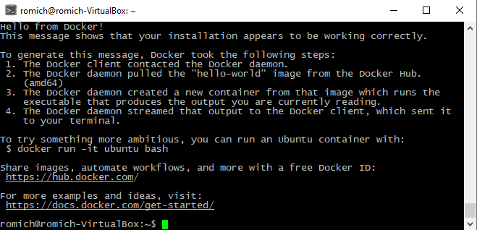
Step 1.2
- Create daemon.json and fill it to enable Docker BuildKit default
$ sudo nano /etc/docker/daemon.json
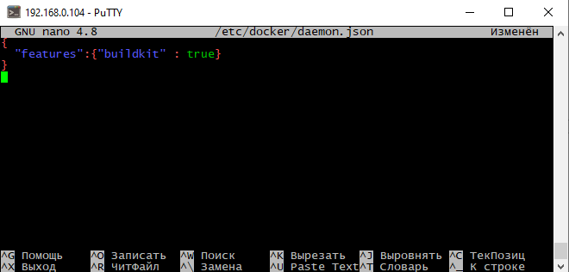
$sudo /etc/init.d/docker restart
- Add the NodeSource package signing key
$KEYRING=/usr/share/keyrings/nodesource.gpg

$curl -fsSL https://deb.nodesource.com/gpgkey/nodesource.gpg.key | gpg --dearmor | sudo tee "$KEYRING" >/dev/null
$gpg --no-default-keyring --keyring "$KEYRING" --list-keys
- Add the desired NodeSource repository
$VERSION=node_17.x
$KEYRING=/usr/share/keyrings/nodesource.gpg
$DISTRO="$(lsb_release -s -c)"
$echo "deb [signed-by=$KEYRING] https://deb.nodesource.com/$VERSION $DISTRO main" | sudo tee /etc/apt/sources.list.d/nodesource.list
$echo "deb-src [signed-by=$KEYRING] https://deb.nodesource.com/$VERSION $DISTRO main" | sudo tee -a /etc/apt/sources.list.d/nodesource.list
- Update package lists and install Node.js
$sudo apt-get update
$sudo apt-get install nodejs
- Do primitive REST API with Node.js
$mkdir node-docker
$cd node-docker
$npm init –y
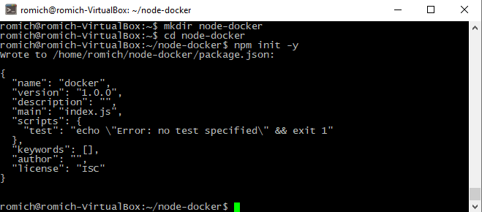

$npm install ronin-server ronin-mocks
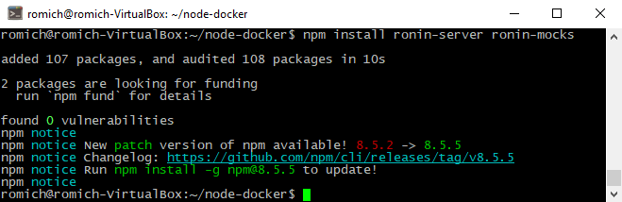
$touch server.js
$nano server.js
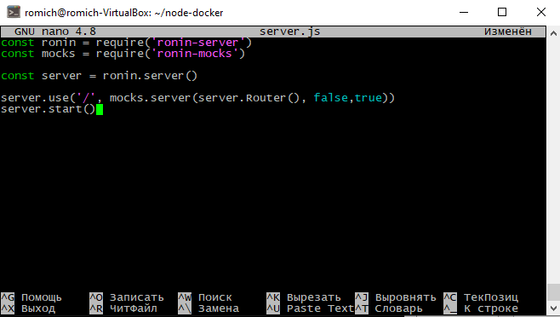
- Start server
$node server.js

- Test with JSON POST request in API
$ curl --request POST \
--url http://localhost:8000/test \
--header 'content-type: application/json' \
--data '{"msg": "testing" }'
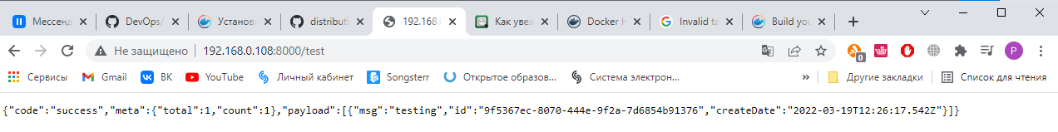

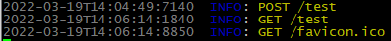
- Create dockerfile
$touch dockerfile
$sudo nano dockerfile
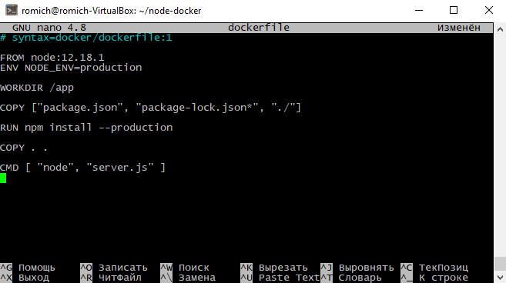

- To improve performance, exclude files and directories by adding a .dockerignore file
$touch .dockerignore
$sudo nano .dockerignore
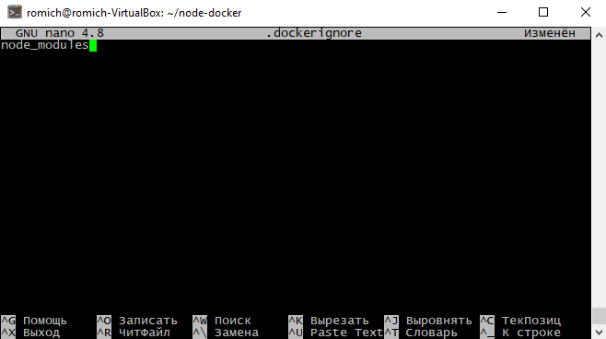
$sudo chmod 666 /var/run/docker.sock
- Create a Docker image
$docker build --tag node-docker .
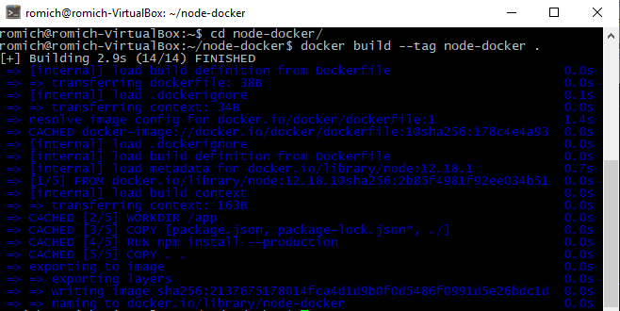

- Run a Docker container on port 8000
$docker run --publish 8000:8000 node-docker
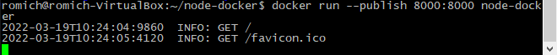
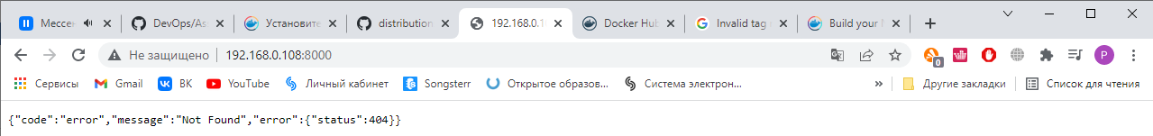
Step 1.3
- Create new repository
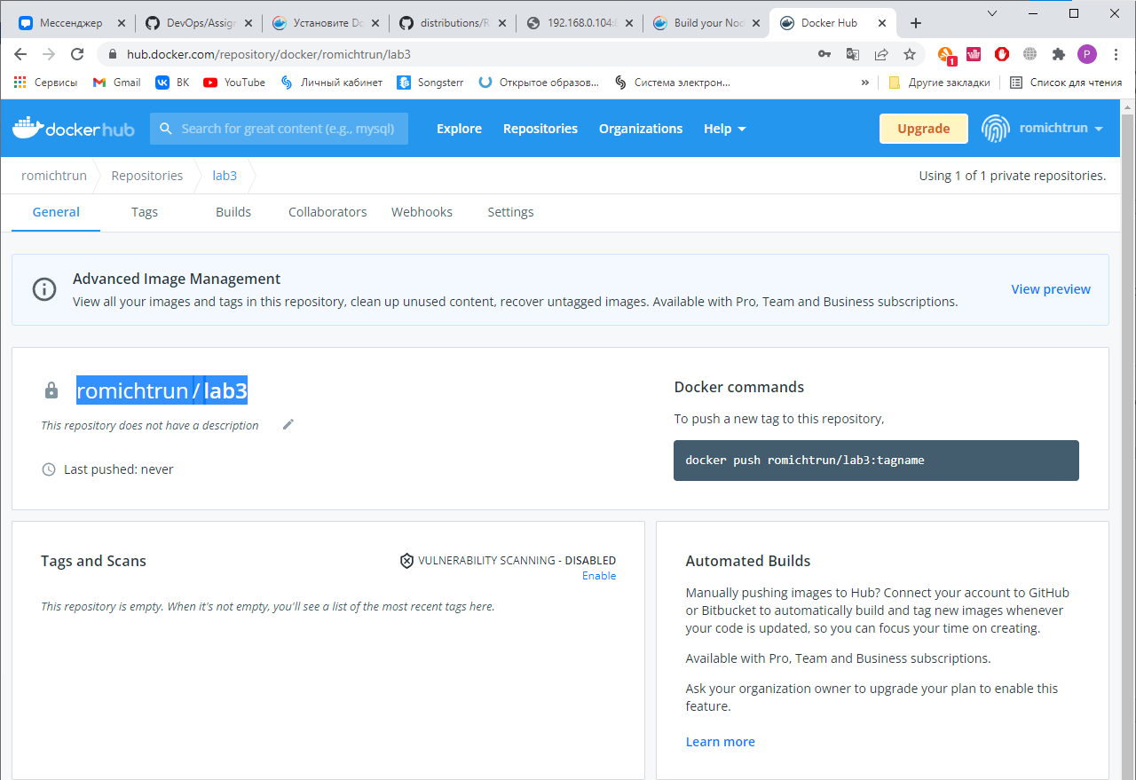

- Push Docker-Image to Docker Hub
$docker build -t romichtrun/lab3 .
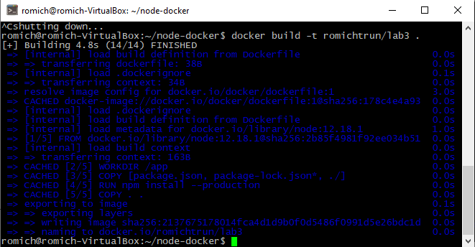
$docker login
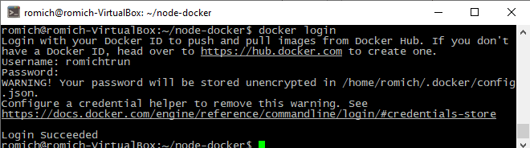
$docker push romichtrun/lab3
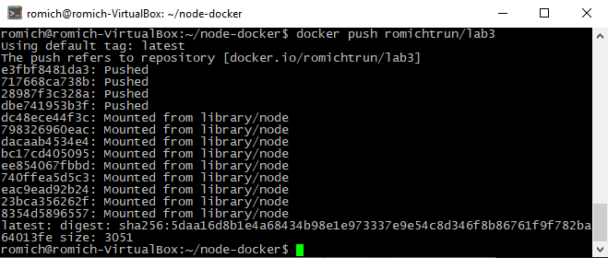

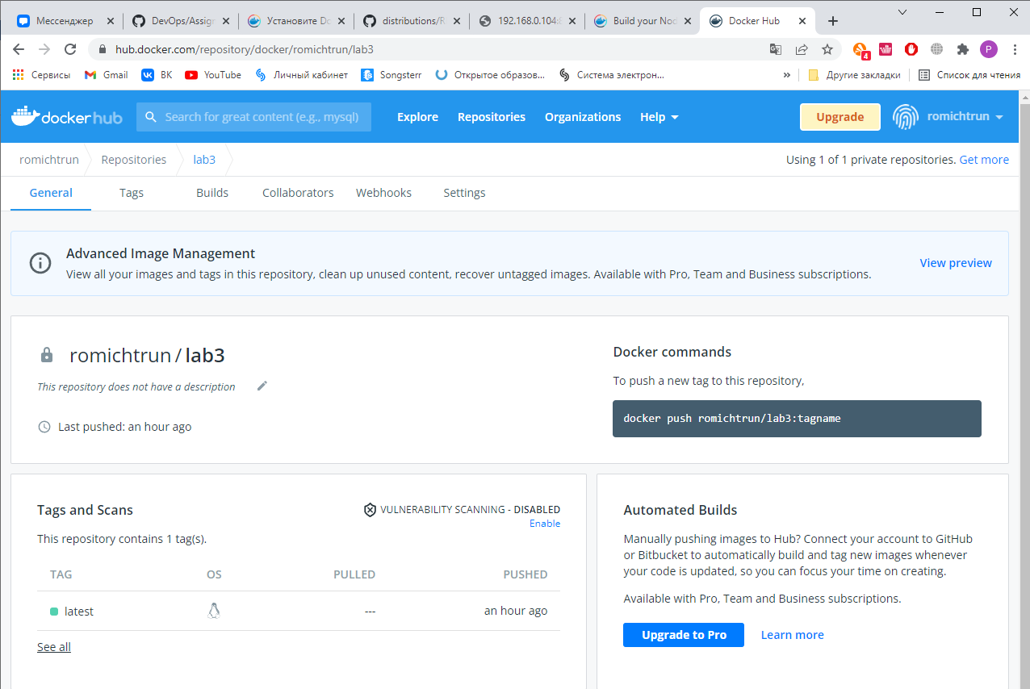
Step 2
Install files from
https://github.com/j-avdeev/DevOps/tree/master/Assignment3%20Docker
Directory name must contain only lowercase characters
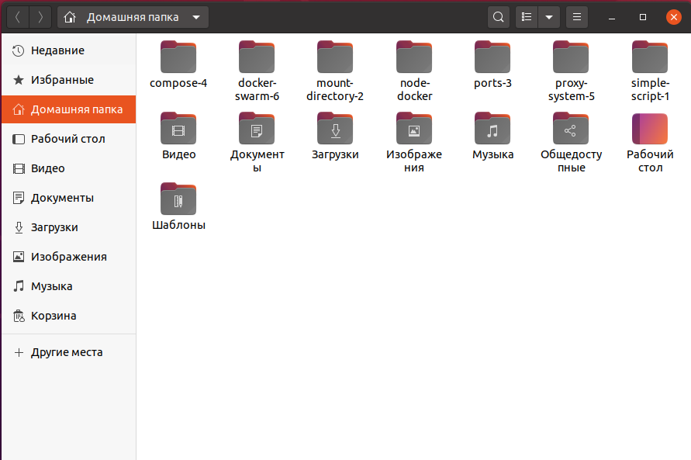

Step 2.1
- Create and run Docker container with python-application
$cd ..
$cd simple-script-1/
$sudo docker build -t simple-python:0.1 .
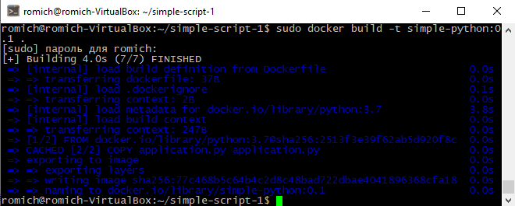
$sudo docker run simple-python:0.1
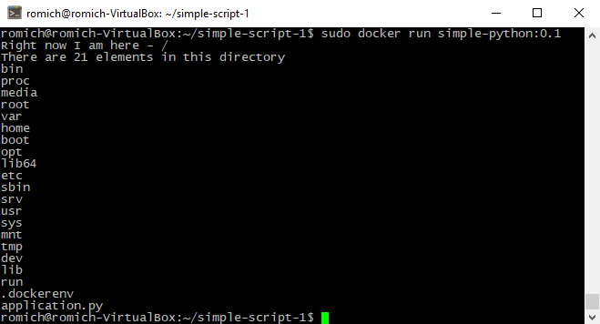

Step 2.2
- Create and run Docker container with directory mounting
$cd ..
$cd mount-directory-2/
$sudo docker build -t python-mount:0.1 .
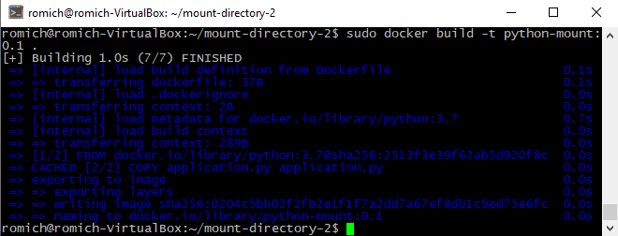
$sudo docker run -v ${PWD}:/mount-dir python-mount:0.1 /mount-dir
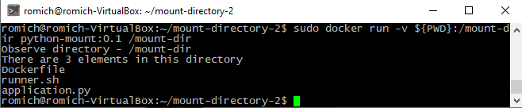
Step 2.3
- Create and run Docker container with port forwarding
$cd ..
$cd ports-3/
$docker build -t python-server:0.1 .
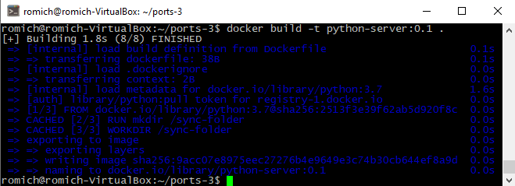
$docker run -v ${PWD}:/sync-folder -p 9090:8080 python-server:0.1
- Check for success
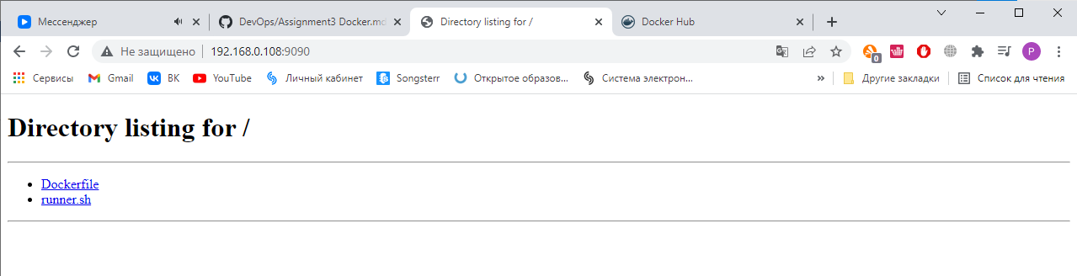
Step 2.4
- Installing LTE version of Docker Compose
$cd ..
$cd compose-4/
$sudo curl -L "https://github.com/docker/compose/releases/download/1.29.2/docker-compose-$(uname -s)-$(uname -m)" -o /usr/local/bin/docker-compose
$sudo chmod +x /usr/local/bin/docker-compose
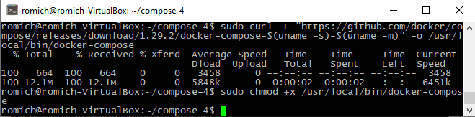
- Fix mistake on line 6
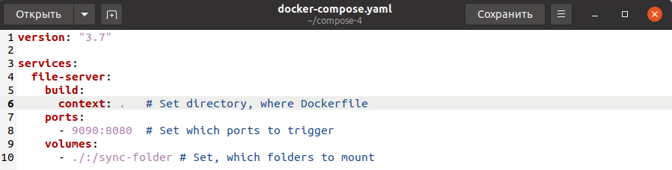

- Create and run Docker container with docker-compose
$sudo docker-compose up
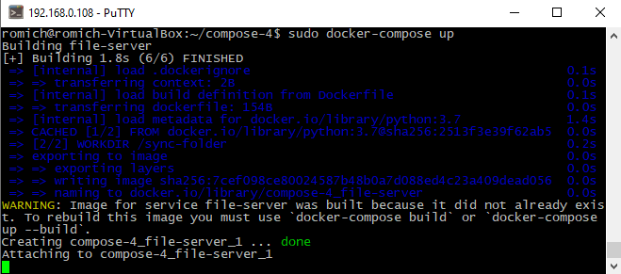
- Check for success
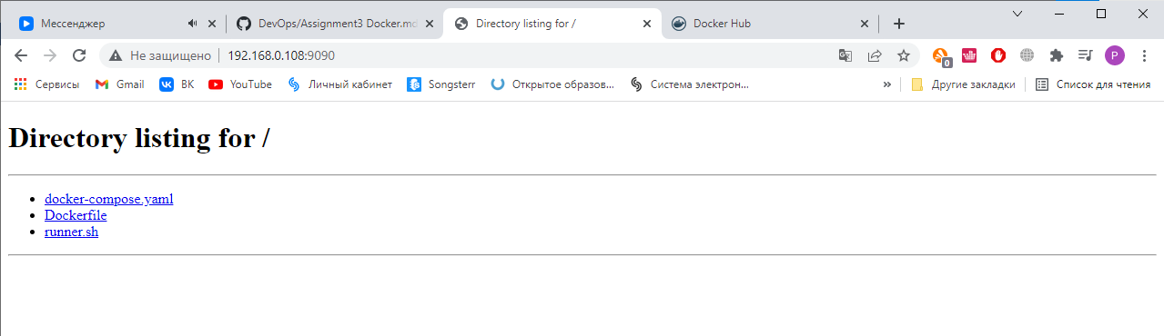
Step 2.5
- Create and run Docker containers with load distribution
$cd ..
$cd proxy-system-5/
$sudo docker-compose up
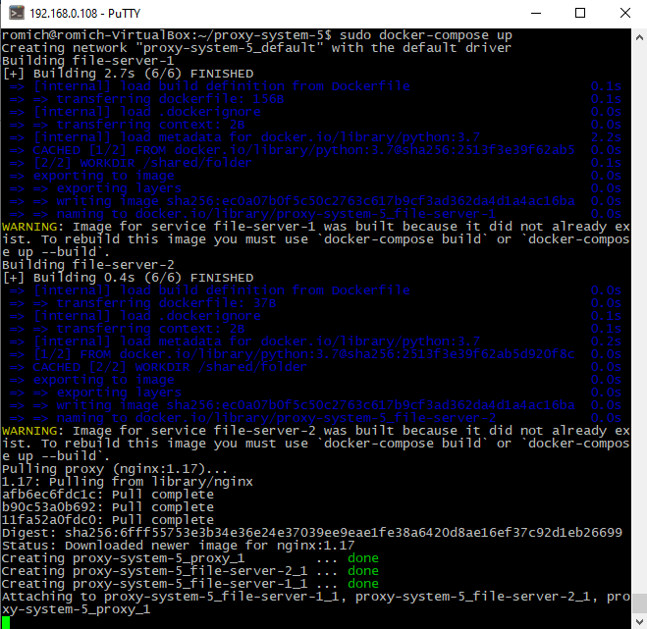
- Check for success
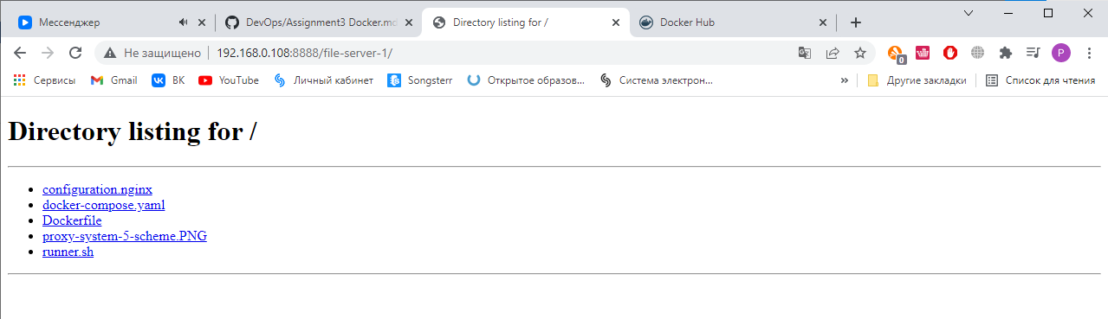

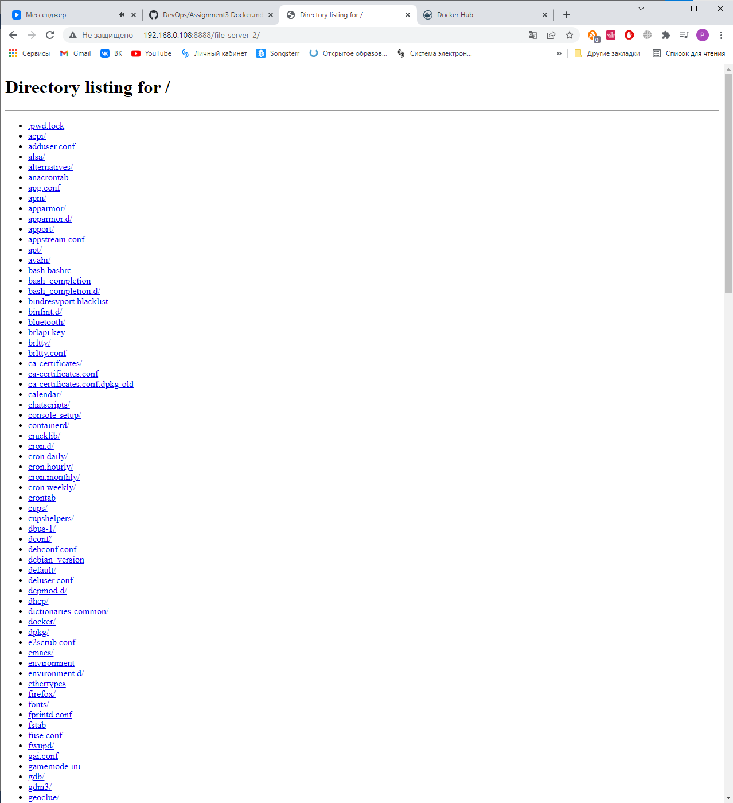

Step 2.6
- Create 3 VM on https://labs.play-with-docker.com/ and create files docker-compose.yaml, configuration.nginx and run-vis.sh on node1
$touch docker-compose.yaml
$touch configuration.nginx
$touch run-vis.sh
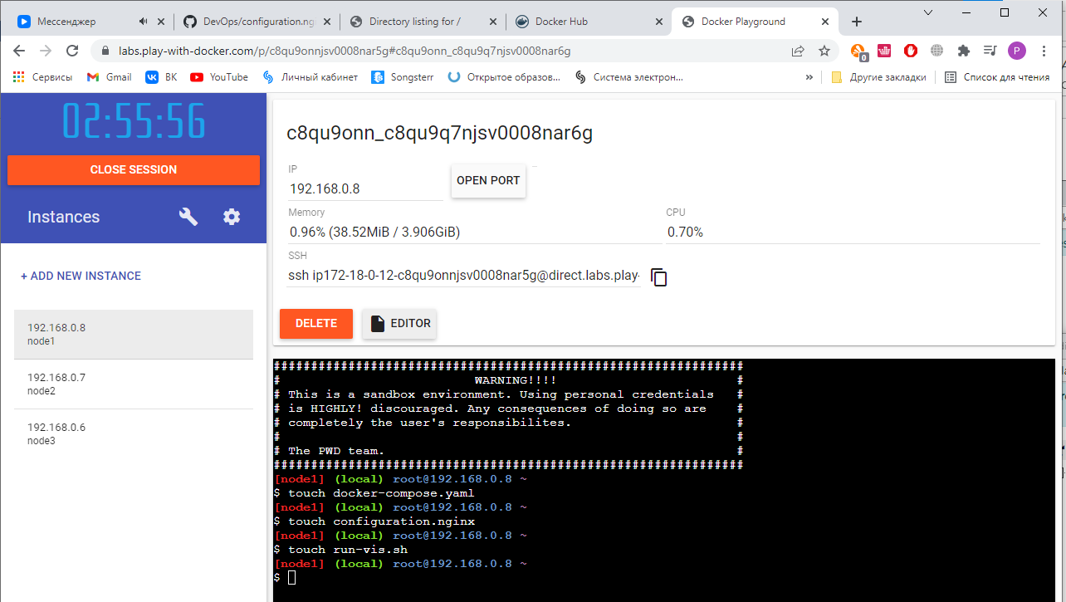
- Fill files with content of https://github.com/j-avdeev/DevOps/tree/master/Assignment3%20Docker/docker-swarm-6
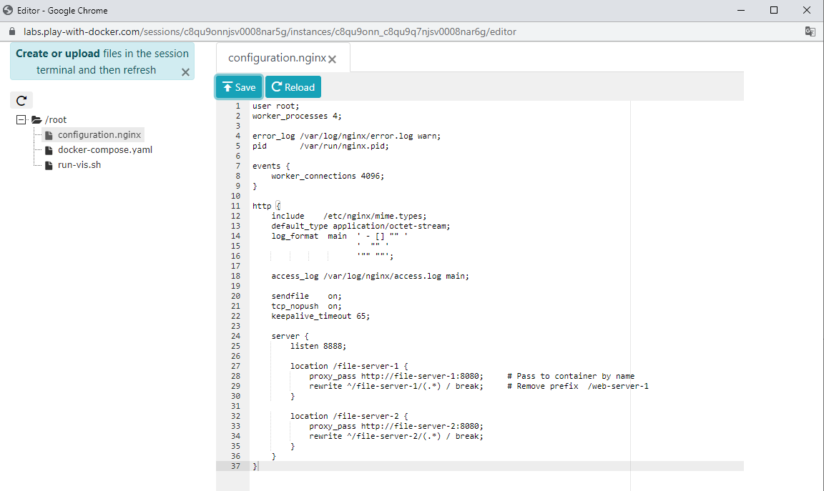

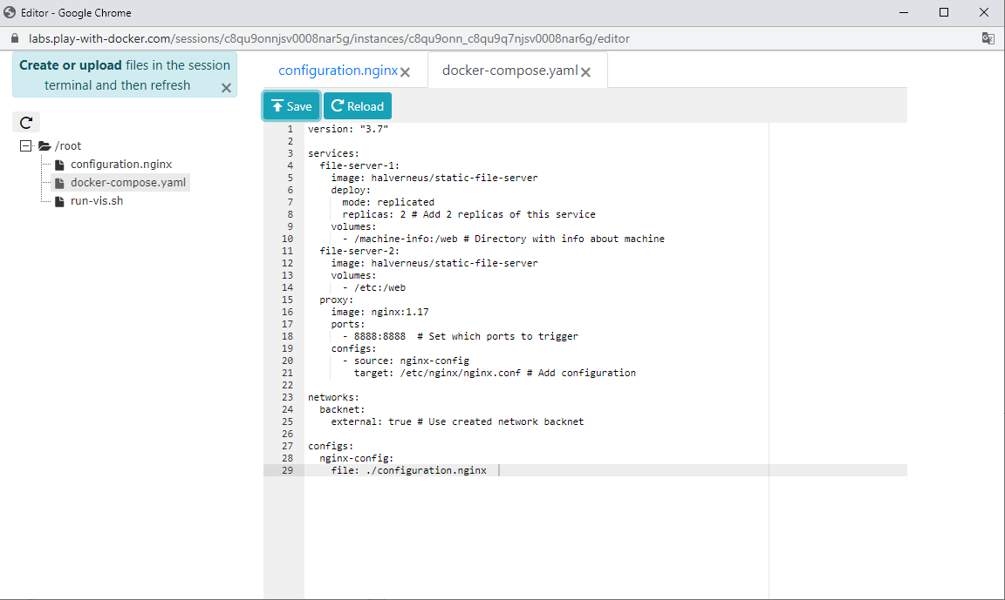
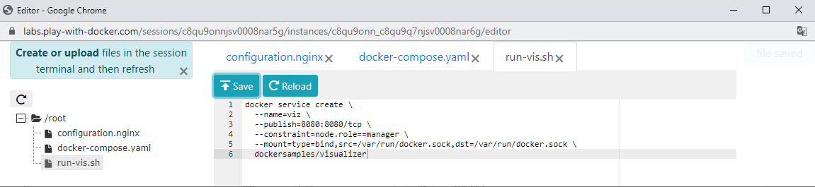
- Node1 assign manager mode
$docker swarm init --advertise-addr 192.168.0.8
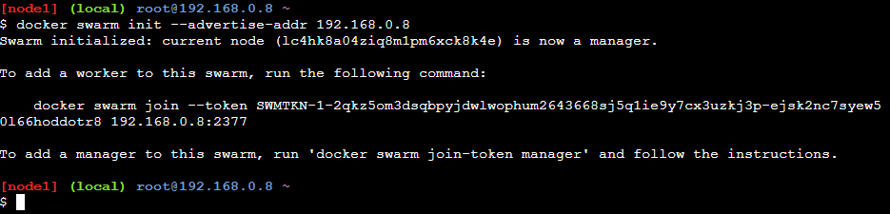
- Attaching node2 and node3
$docker swarm join --token SWMTKN-1-2qkz5om3dsqbpyjdwlwophum2643668sj5q1ie9y7cx3uzkj3p-ejsk2nc7syew50l66hoddotr8 192.168.0.8:2377
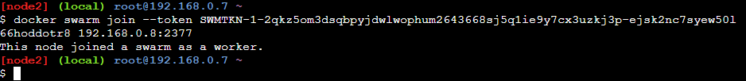
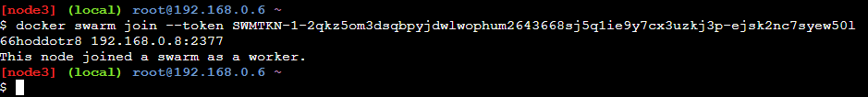
- Copying the Docker Swarm Visualizer Repository
$git clone https://github.com/dockersamples/docker-swarm-visualizer
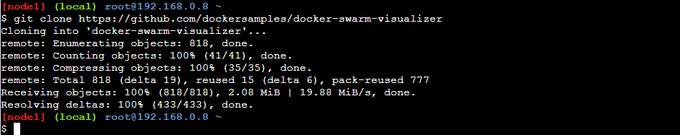
- Running docker-swarm-visualizer
$cd docker-swarm-visualizer
$docker-compose up –d
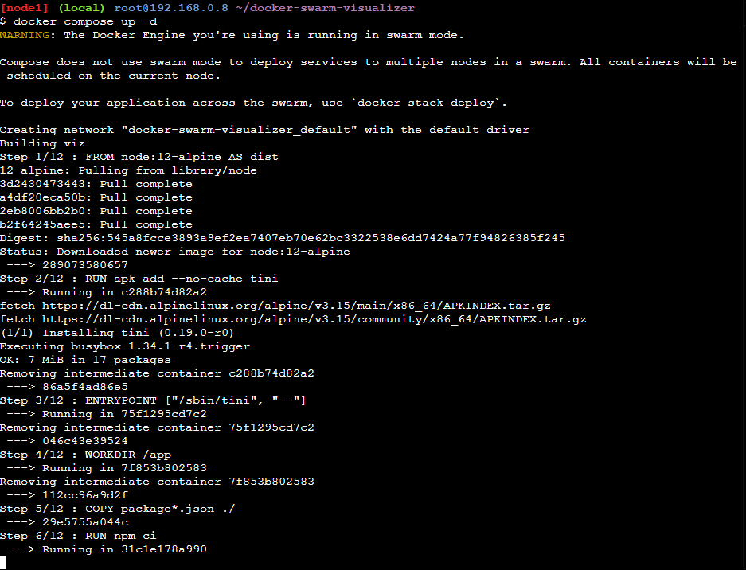

- Check for success
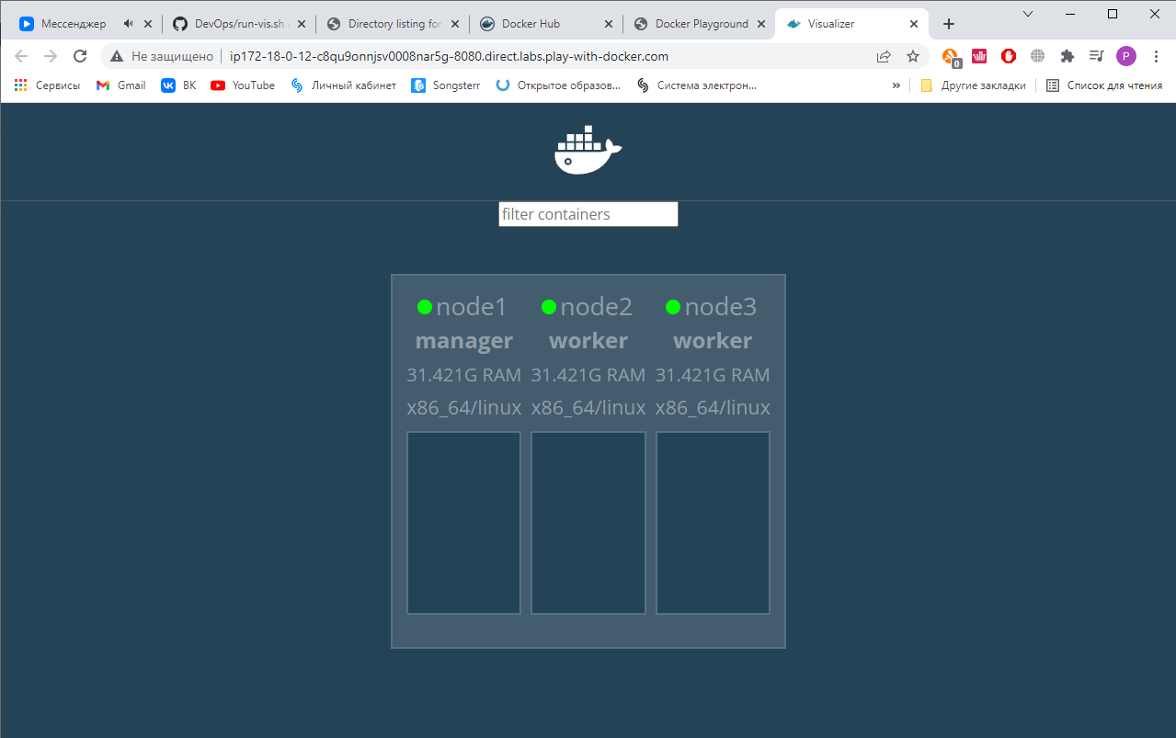
- Application deployment
$docker network create --driver overlay backnet
$cd ~
$docker stack deploy --compose-file docker-compose.yaml file-server
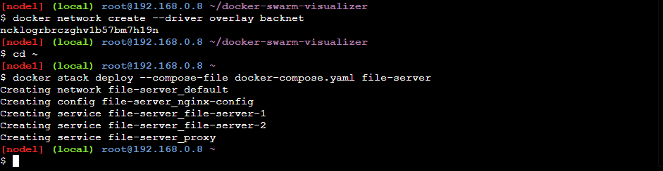

- Check for success
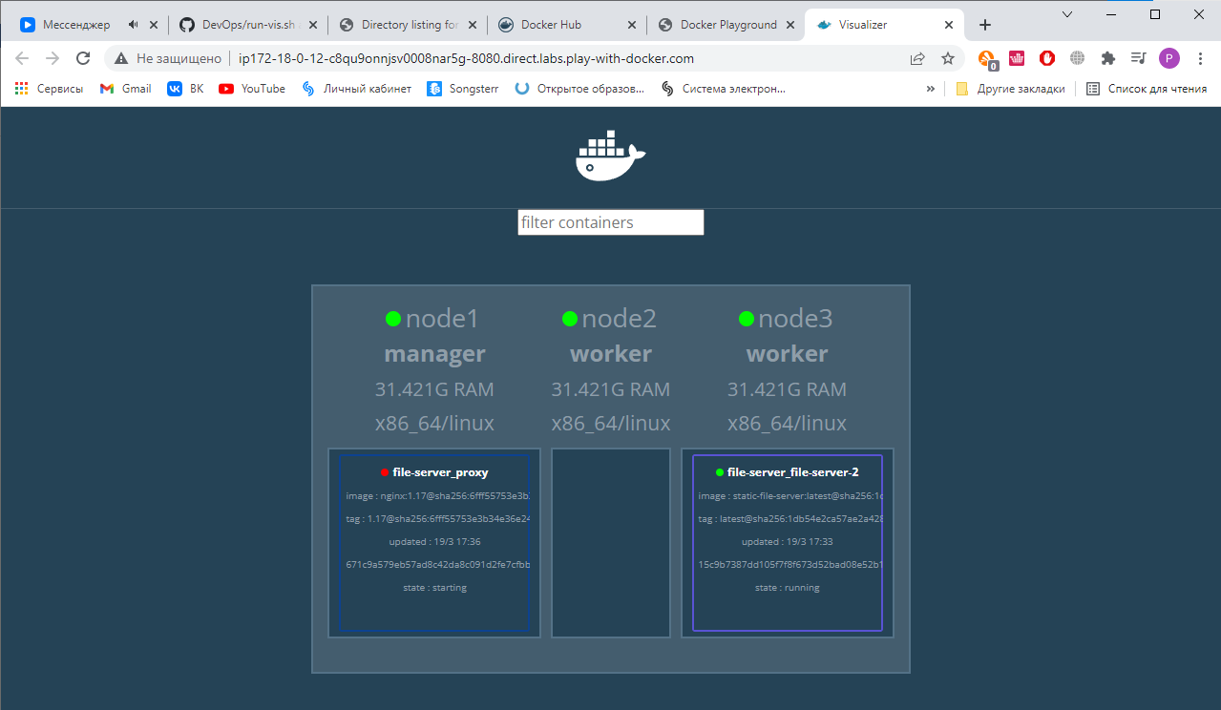
- Fix mistake in docker-compose.yaml on line 10
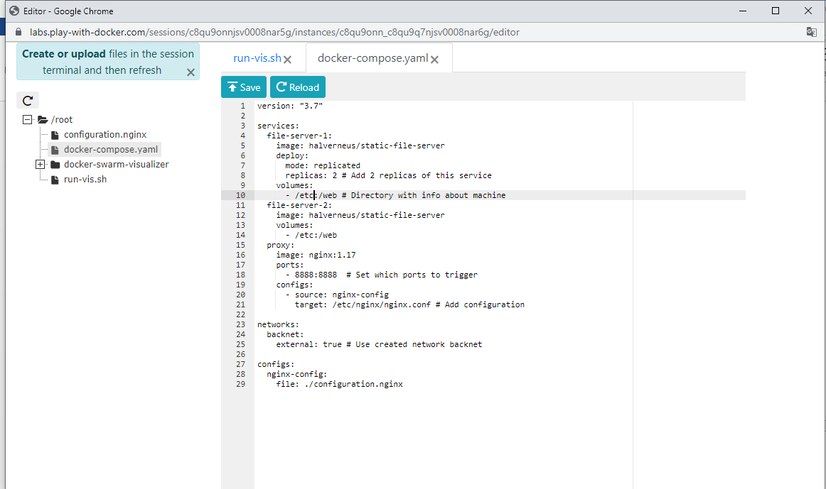
- Application deployment
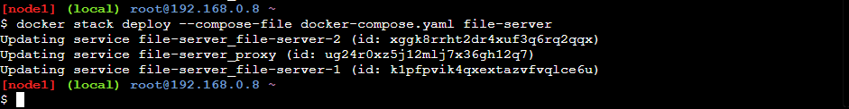
- Check for success
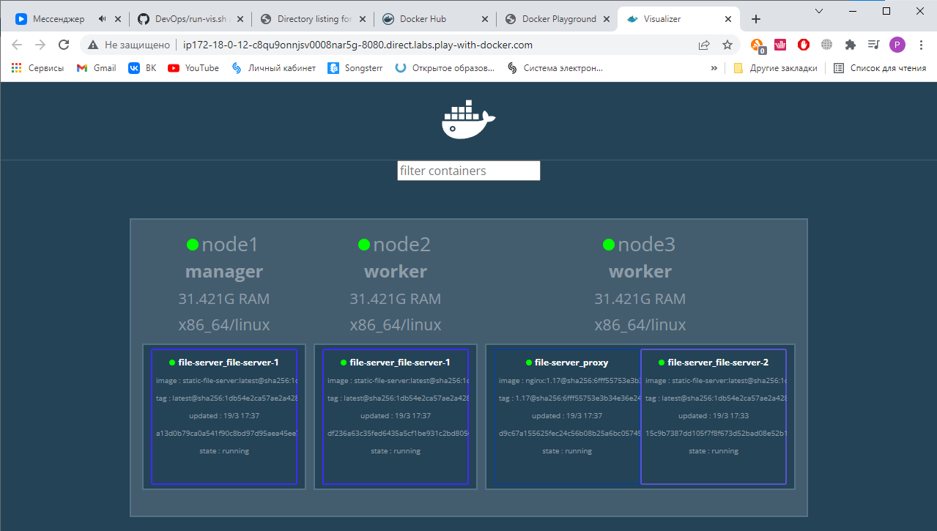

Conclusion
In the conclusion, we studied the basic utilities of Docker for working with container, and Docker-Swarm, all steps completed successfully.

